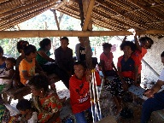
AETA MISSIONS REPORT
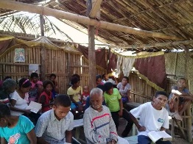
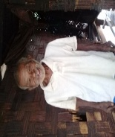
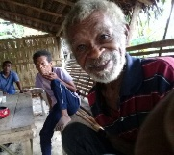
January and February 2018
NEW LIFE BAPTIST CHURCH, TARIK, PLANAS
AND PASBUL AETA MISSIONS, Porac,Pampanga
Missionary Rex Daryll D. Lalu
email.daryll317lalu@gmail.com/09350551527
Sending church : New Life Baptist Church, Pandacaqui, Mexico, Pampanga
Sending Pastor: Jeremy Ferguson

Dear praying partners, Pastor, and church,
We want to share with you how God moved His hands as we further the preaching of the Gospel. And we are thankful for your partnership with us to preach the gospel for the aeta people. In the past two months we experienced joy and sadness in this kind of ministry.
Church Meetings
By the grace of God, He hath given us new precious visitors
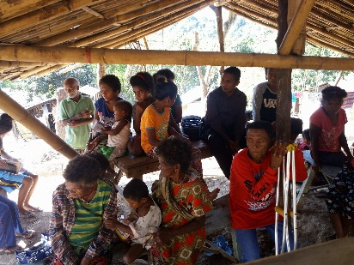
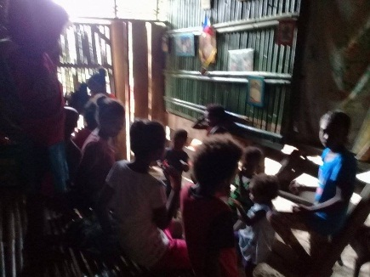
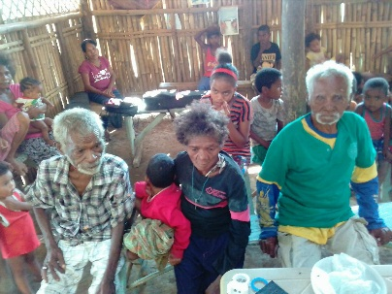

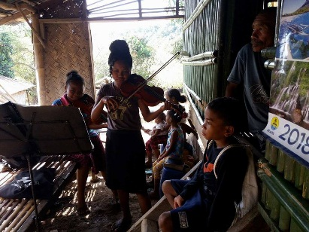
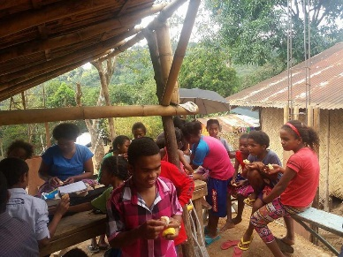
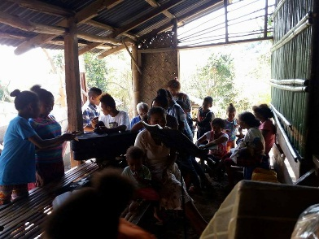

January was the last time we gathered in the hut we used to worship in, because God allowed us to start building a concrete-made . By His grace we had families who are regularly attending until now. Please pray for Pineda family and Sibal family. We also had the chance to reach new people who are interested in Planas and Pasbul.
At the month of February, one of the members of the church was gone to heaven, Bro. Rodrigo,
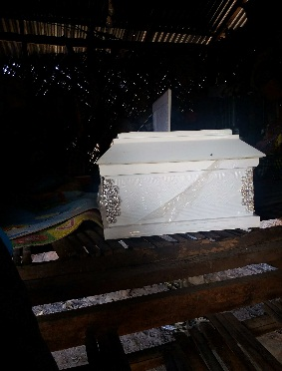
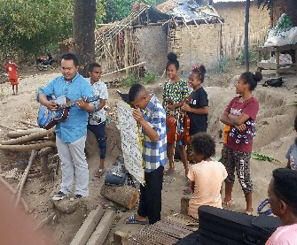
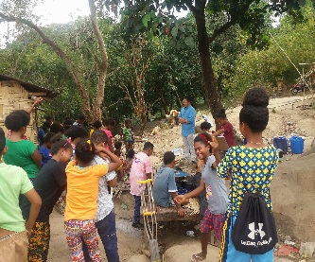
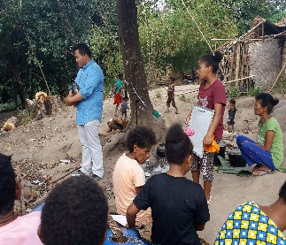
.

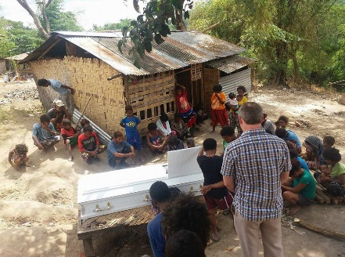
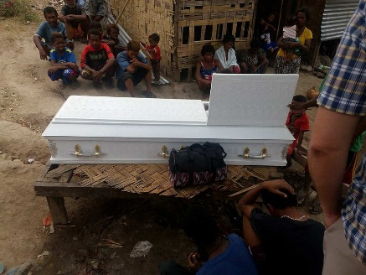

Bro. Rodrigo Santos was one of the first member of the Church, a very humble, joyful, and serious servant of the Lord. But in the past 2 years a very serious mouth disease that causes him to be weak and became skinny. This February 2018, He peacefully went home to heaven. And at his wake, we thanked the Lord for having the great chance to preach the gospel to his relatives in different places. And God really moved to their hearts as those relatives continually attending in our church meetings.
We are really sad , but it is with hope, God really taught me something regarding the mission matter. He lets me realized the importance of immediate and persevering act for the lost souls before its too late. Yes we cried, not because I’m sad, but because it really hurt on how could I didn’t go in the time when their strength is there. But by His grace it is still best as bro. Rodrigo received Christ as his Saviour. Please pray for sis. Bella and his family. And for the salvation of his relatives.

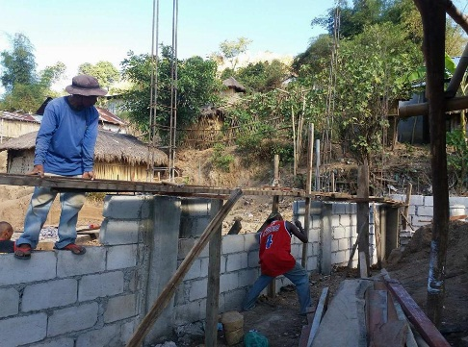
Church Building
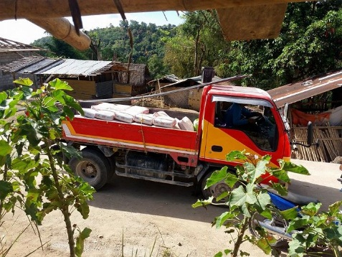
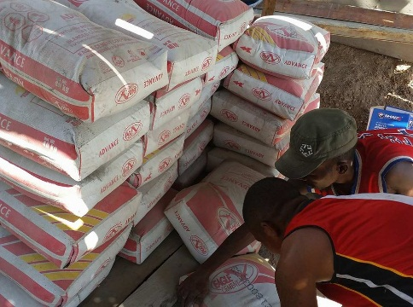

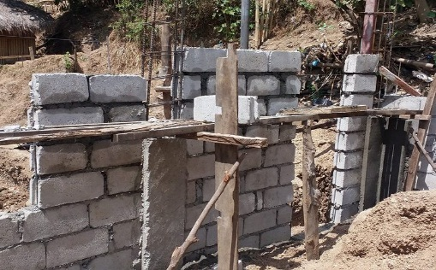

Planas Church
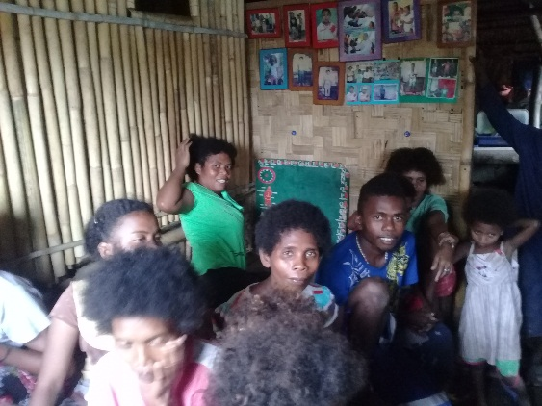
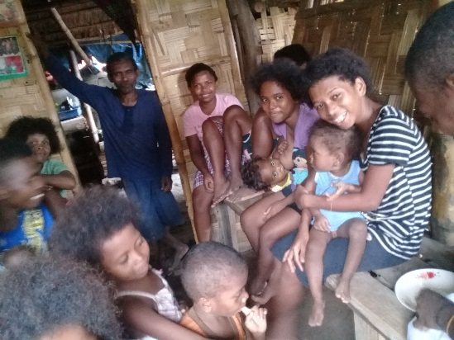

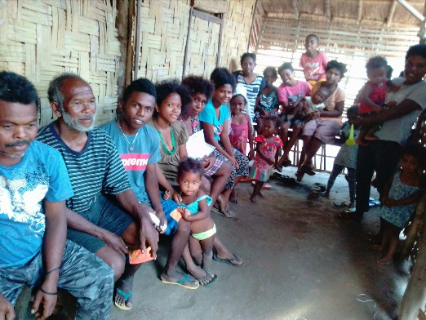

By God’s grace, newly baptized were faithfully attending and giving their faith promise missions. We are also lifting up prayers for our new visitors that they received God’s gift of salvation. We were also asking prayers for Sis. Jonabee Cabalic because of a skin disease that she’s suffering until now.

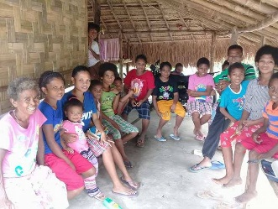
Pasbul Missions
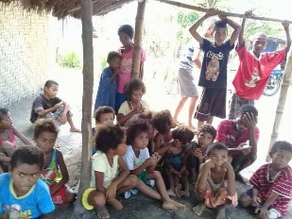
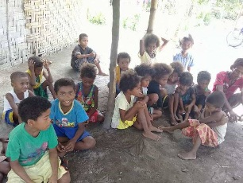
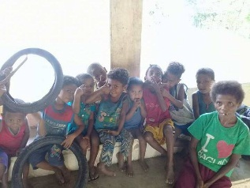

Please pray as we, the bible school students were preparing by this march that they will minister together with me both in Planas and Pasbul places that we may reach more souls in the said places. By the grace of God we were able to preach the gospel to the lost souls here at Pasbul. Please pray that someday there would be a man of God that will strand, preach, and spread the truth in this place. Please pray for Bro. Jojo, Onyok, Edu, Miracle, and Bro. Mario.

PRAYER REQUESTS

-More Pastors and Missionaries.
-Bible School students
-Building Project
-To reach more souls in the villages Villa Maria, Planas, Pasbul.
-More souls to reach out and to be saved.

Your fellow-labourer in God’s vineyard,
Bro. Rex Daryll D. Lalu

