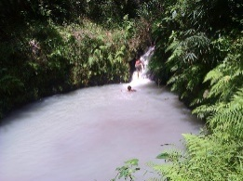
MISSION REPORT
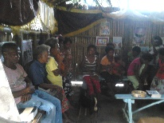
SEPTEMBER 2016
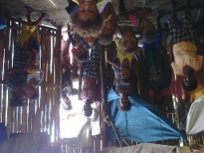
NEW LIFE BAPTIST CHURCH TARIK,PLANAS
Porac, Pampanga

Dear praying partners,
We thanked the Lord for your unceasing prayers towards the ministry of the Lord for the Aeta people. This month has been a fruitful month for us as the Lord added and about to add 10 more souls to the church. We have finished the membership class for these people. We had the increasing numbers of visitors and continuing visitors both in Tarik and Planas, one thing that we need to take time to observe are those people who are not genuinely professed faith and then go away.
We are not surprised towards this but we should be alert so that we can keep the Lord’s house clean. This month, many adult visitors want to be baptized but still they want to continue in sin that’s why we did not allow them but we told them that they should bring forth fruit meet for repentance. One thing that I have noticed why God did not allow us to go in a clean, comfortable , fresh water but instead on a very unnecessary form of water filled with leeches is to test how serious these people really are to follow God’s command. In fact, this small river was the safest river out of the three rivers on Tarik that I only had 3 bites and sucks of these leeches. We praise God for these provision and to prove these people how serious they were even to do little things for the Lord.
This last week saddened our hearts because our brother Tino’s wife, Conchita Sibal passed away last Saturday afternoon at the age of probably 90, they don’t have birthdays even to know their ages. Brother Tino allows us to share the gospel to their great number of family members and a lot of them listened and told us to visit them for personal evangelism. Brother Tino was really concerned about his family’s spiritual state. Please pray for Sibal family for comfort and to be an eye-opener that life is like a vapor.
Please pray also for our activities in the church at Tarik , for we are now planning to continue the building program to build a place for our church. Last time we had a little problem due to the land because the barangay officials there thought we were robbing their land that it cause us to cancel our building preparation for a while. Now a lot of members were offering their land to build a place for church congregation, praise God for His Provision! We as a church did not teach members to asked alms from other people for church building, we let them give and earn through their faith from God so that they may know how God’s hand move on themselves rather than asking money from others. We know that even from little by little process God will let these people know the importance of putting their faith in him and not on people.(psal.118:8)
Please pray also for next batch of baptisms that we have . there were two people who were newly residence of our place , Bernadeth, a mother, and Daniel, a young man came from Zambales raised their hands as we asked invitation to receive Christ. We are having bible study on their home regularly so that they may fully understand God’s word.
Please pray also for our mission points in planas and pasbul(camias) that God sends missionaries on these places . a lot of people were regularly listening on bible studies on these places that everytime we go there, our hearts always cry that we want to stay and let them be filled with God’s word .only if we can cut ourselves so that we can put it on these places we will do, but we know that God will provide. Please pray for more missionaries to surrender. Even though I’m not like these aeta people, I feel their loneliness once they were discriminate by others about their life and I myself was discriminate by others for telling and asking me, why did you choose that nonsense thing?? This broke my heart, but as God lets me teach others, He also let my hearty be taught on these mission field, that as a christian, you are not of your own, but God’s. maybe many people don’t want to surrender in this kind of field because they were afraid to be discriminate,to pull down, please pray that God open the heart of men to go before anyone dies.
Again we really thank you for taking time to read this report. May we ask that you always remember us on your prayers. And we are praying for you too. Thank you and God bless.

Your brother in Christ,
Bro. Rex Daryll D. Lalu
Prayer Requests
- Pray for Tarik,planas,and Camias for more souls to be saved.
- Pray for church to grow in number and grace
- Pray for Sibal family
- Pray for new believers to grow in grace
- Pray for our building program in Tarik.
- Pray for our bible school students
- Pray for God’s grace and provision in all of our needs for the ministry
- Pray for more genuine missionaries.

Pictures.
