Please pray for us ALWAYS!   | Philippine Missions  September / October 2010 Prayer Requests and Newsletter  The Ferguson Family – www.jeremyferguson.org  Highland Baptist Church  Gainesville, Florida (352) 373-2138 - www.highlandsmbc.org | 

Dear Praying Mission Partners, November 1, 2010

On October 23, 2003 I arrived in the Philippines and have been here ever since. After nearly seven years of missionary work here, I’m extremly excited to see and report on everything that God has already accomplished and I can already see glimpses of even greater things to come! By the grace of God I have already become 100% fluent in the national language here in the Philippines and have learned a lot of the local dialect in Pampanga. Two Churches have been established as well as a Bible School where people are being trained for the ministry. The Church in Pampanga is close to 250 in attendance and the Church in Nueva Ecija is close to 50 in attendance. Both of these churches are growing quickly in number and are already financially supporting local AND foreign mission works! I believe that true success in mission work is when people are truly saved, local Churches are founded which will be led by godly, native leaders, and these churches are becoming truly missions-minded. We have already seen great success and are only praying and preparing for more!

Training up godly leaders is one of the most difficult aspects of this all, but God is doing mighty things! All of the people whom we are training are our own converts whom we’ve personally won to the Lord and whom I am personally teaching in our Bible School. I’ve found that many missionaries go out and find recent graduates from other Bible Schools, offer them money to work for them, and then claim that they’ve done all the work. Here, however, there are no lies, gimmicks, or number padding schemes in the ministry we are conducting for the Lord. Our Bible School is now producing Filipino preachers who are able to lead the Lord’s flock. The exciting thing is a good number of young men who are in the Bible School who have their entire lives before them to serve the Lord! Please pray for them to become godly leaders and for others to hear the call to ministry work also.

We’ve also taught the people here to faithfully support their churches financially and we see them being obedient. I’ve found that many churches started by foreign missionaries are still riding on foreign financial support and these churches would almost come to a complete stop if the foreign financial support was unplugged; this definitely isn’t God’s will. Nobody is too poor to give and they must simply be taught what God’s Word says about giving and be challenged to do so.

Over the past seven years I’ve been approached by many Filipino Pastors who are looking for financial support. As a foreign missionary from America you gain immediate fame in the eyes of those who look at you as a walking money tree, but that fame quickly fades and smiles become frowns when I tell them, “silver and gold have I none”. Some even think that it’s the duty of a foreign missionary to bring financial support to them. I’ve tried telling them to be faithful in teaching their members to give yet I here the same thing always, “They’re too poor to give”, etc. I tell them how the poor members in our churches are giving faithfully and support their local church and even other mission works, but they don’t seem to have faith that God can do this and that’s usually about the time they stop communicating with me.

I’ve taught our people that while we are in a mission field they should have a burden for other mission fields also. Please pray for our ultimate vision, which includes sending out missionaries to OTHER NATIONS nearby the Philippines. We are praying that one day God will send out missionaries from the churches we’re starting to carry the Gospel to other nearby nations such as China, Indonesia, Cambodia, Vietnam, Thailand, India, Sri Lanka, and even the muslin nations in the middle east. It’s very difficult for American missionaries to work in these types of nations which are closed to mission work, but the Filipinos can blend in very easily and are quick to learn other languages and cultures.

I’ve also been involved in teaching and encouraging other Pastors and churches about the responsibility of every Christian to be involved in the Great Commission. I’ve been able to preach some mission messages in some other places throughout the Philippines and I was recently invited to preach at a mission’s conference in Cabanatuan, which is only about two hours from where we are currently located. We also had a terrific missions day this past September 12 at the church in Pampanga. There was a lot of missions teaching and preaching and I took some time to show them some videos about William Carey as well as the story of the five American missionaries killed in taking the Gospel to the Auca Indians in 1956. It was a great day as we saw more commitment to missions work and an increase in financial giving to missions.

As I mentioned above, Church attendance is doing really great and we are seeing several professions of faith every week. We were very excited to have record attendance of over 50 at Nueva Ecija recently! Please pray for greater attendance and many new believers who are preparing to be baptized from Pampanga as well as from Nueva Ecija!

Please pray for God’s protection against attacks from the enemy. The Lord told us that the gates of hell would open up and so there would be many battles, but God is far stronger and as we pray to Him and seek His face He will protect us. Throughout the years there have been several families who have tried to come in to the church with wicked motives of causing problems and divisions; we recently dis-fellowshipped an entire family of eight who were trying to cause division. We gave them the chance to repent, but they said they didn’t want to. Yet the church continues to grow in number and in faith, praise God for his protection and blessing!

Please continue praying for Sis Nenita and Emily from Nueva Ecija. As I mentioned recently, they are both going through very difficult times in their lives. Please pray for them and for their family members to be saved also.

We want to thank all of our brethren back home at Highland who are so faithful in supporting this ministry with their sincere prayers and financial sacrifices. We are all working by total faith together as Highland is the only church financially supporting this ministry on a monthly basis. Paul did mission work the same way back in his days and he said in Phi 4:15, “no church communicated with me as concerning giving and receiving, but ye only.” Let us remember that our God is not limited and He can use small people to accomplish great things! Brethren, the truth is that there are many missionaries with many churches supporting them with thousands of dollars every month, and yet there is very little fruit to see. In fact, there are some foreign missionaries who are living better off on the field than they would be back home in the States; we call them tourists not missionaries. It’s not uncommon to find them with nice SUV’s, a nice home in some subdivision built for the rich, and personal maids and servants. Most people have wrongly assumed that I’m here with $3,000-$5,000 of monthly support. We have a tricycle for transportation, wash our own clothes, cook our own food, and are preaching the Gospel to multitudes here. Remember that God is just looking for people who will go and preach the Gospel! As the dollar-to-peso exchange rate continues to fall and others run back to the states to find more financial support we will stay here and continue carrying the Gospel to the lost. God is using Highland in an incredible way, glory to Him for it all and may this continue until He returns!

Everything is doing fine for the Ferguson family here. Some of you asked about the storm that recently came through and it didn’t affect us much besides the loss of power for two days. The winds were very strong and it seemed as if a hurricane was coming through, but God is good at keeping us safe. Joshua is going to kindergarten and learning really quickly. His school has an upcoming field trip to a zoo, but he won’t be able to go along because the trip is on a Friday and every Friday we leave for our weekly mission trip to Neuve Ecija. I asked Josh which he would prefer; field trip or mission trip, and he choose the mission trip. We’re praying for God to give him a missionary heart and it looks like God is already answering! Thanks and God bless you all!

Yours in Christ,
Ferguson Family

Psalms 3:8, “Salvation belongeth unto the LORD…. Pagliligtas ay ukol sa Panginoon.”

* Other Prayer Requests:
- Sharing the Gospel in Public Schools
- Fulltime missionary in Nueva Ecija
- More to study in Bible School

!!! Check out our webpage for more pictures and videos !!!
(Look under the “Multimedia” area)
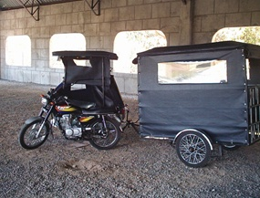+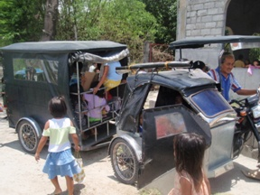
=


This wheel hub literally cracked from all the passenger weight…awesome! The incredible thing is that I continued using the motor two more days before replacing the hub and it still rotated!

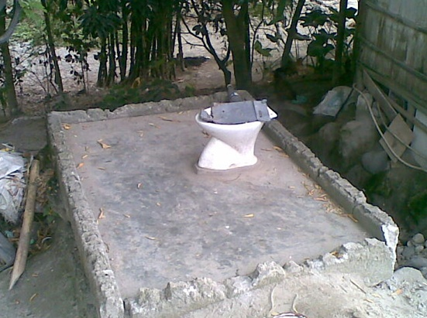
Looking for a bathroom? Look no further!

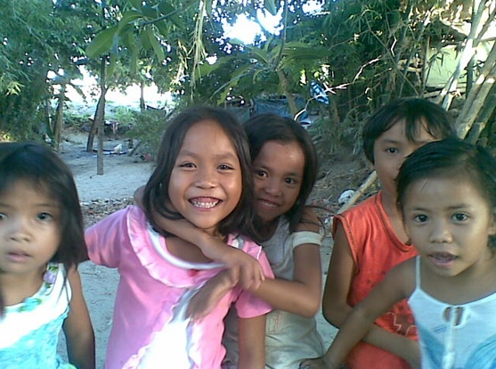
Children at a recent outreach


Children at a recent outreach


Children at a recent outreach

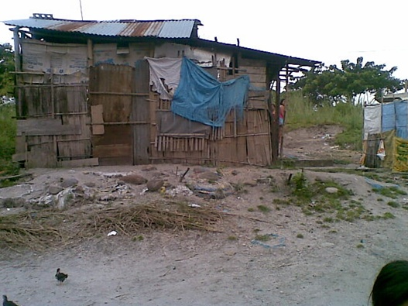
This is what most Americans would call “culture shock”

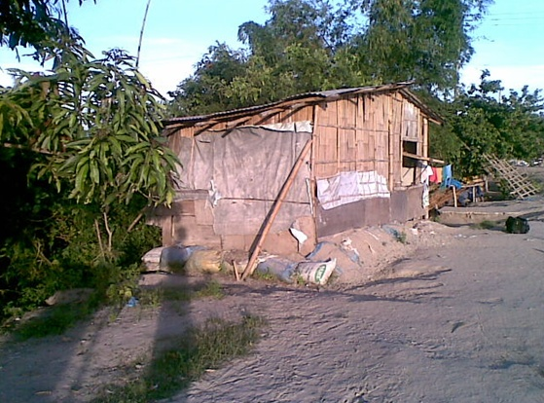
Many people in the Philippines live in small homes made from bamboo


This is a typical homemade basketball hoop

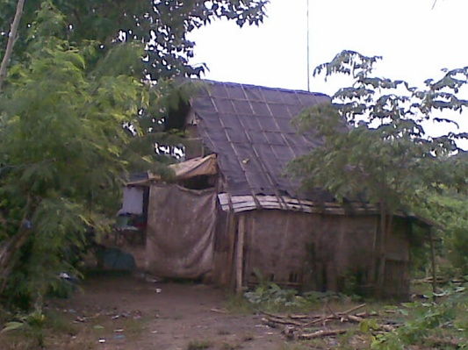
Bamboo house

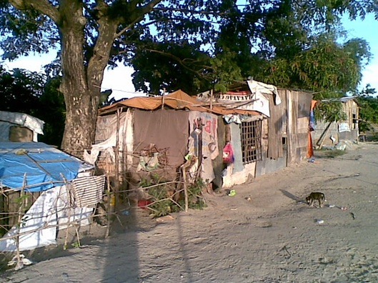
You would be shocked to see how many people live in these homes

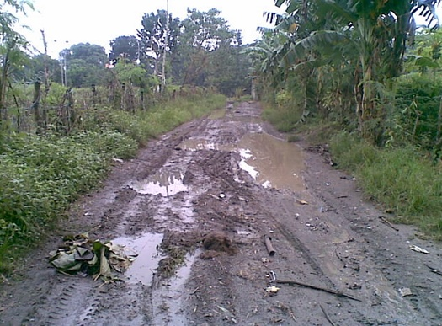
We are willing to go anywhere and through anything to get the Gospel to the lost

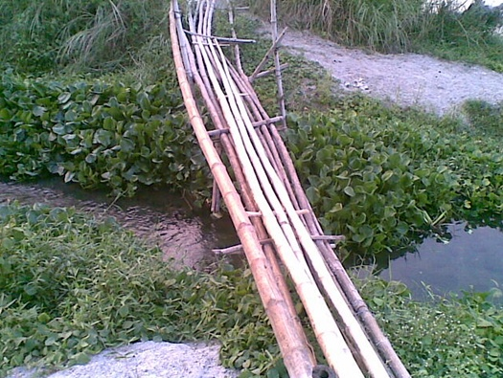
My knees buckle up and shake every time I cross this bamboo-bridge, but we must cross it to get to the lost people on the other side.


Young girl at a recent outreach

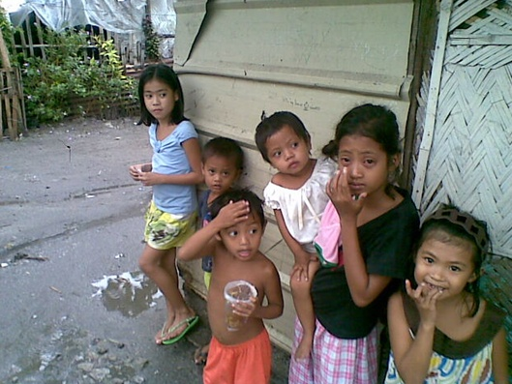
Children at a recent outreach

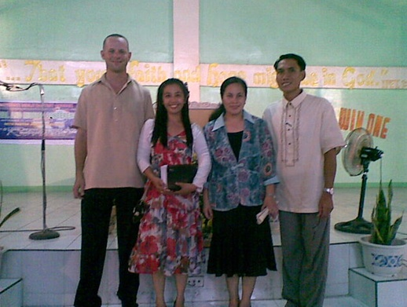
Mission conference at Cabanatuan


Young girl at church

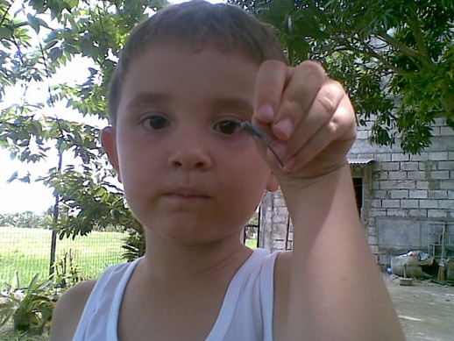
Josh holding a dragonfly he caught

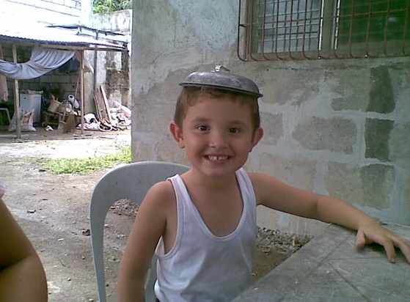
Josh has a new hat!?

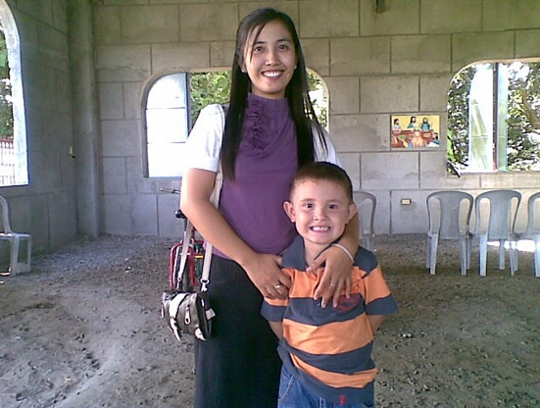
Recent picture of Kristine and Josh

