Please pray for us always!   | Philippine Missions  Jeremy and Kristine Ferguson – May/June 2009 Newsletter  www.jeremyferguson.org - jeremy@jeremyferguson.org  Highland Baptist Church  Gainesville, Florida (352) 373-2138 - www.highlandsmbc.org | 

Dear Family and Friends, July 6, 2009

We thank each of you for all that you have done for us throughout the months of May and June! God has been doing great things here as a result and we ask you to continue praying hard so even greater works for the Lord will come about! We have a group of 17 new believers who will be baptized on July 26th and 10 others who will be baptized towards the end of August. Praise God for these new converts and the victories God is giving us! Please pray for the faithfulness of these people and their Spiritual growth.

In preparing these people for following the Lord in baptism we first teach them a 2 month series of Bible lessons focused on salvation which is followed by another 6 weeks of teaching about baptism and Church membership. I’m coming up on my sixth year here in the Philippines now so I’ve been able to clearly identify what we need to do in order to effectively teach the foundations of the faith to the people here. The beliefs here are deeply rooted in works for salvation so we spend a lot of time teaching new contacts the truth about faith in order to be sure that they clearly understand. It’s a lot of work as we typically do these teachings on a one-on-one basis, but it helps the people here to clearly understand the way of salvation with no confusion. We make sure that each of these people go through all of these initial lessons before they are baptized so that they have no confusion about the faith and what it means to follow Christ in baptism.

One of the exciting things to see from this new group of believers is that many of them are coming from our outreaches in areas that are in surrounding areas from where we are located. We now have members who live next door to the Church and others who come from nearly an hour away to get here; it’s really exciting to see! Also, some of the recent decisions for baptism have come from people whom we have shared the Gospel to in the past, but were not yet interested, but have now come to receive Christ as we’ve followed-up with them. So we praise God that He is blessing us for our perseverance! We continue to see 150+ in attendance at Church and are continuing to strive to our goal of 200 and beyond.

We recently received 24 new Bibles and have almost distributed all of them to people here in Pampanga as well some to people in Neuava Ecija. We thank each of you who gave towards these Bibles as they were a blessing for the ministry here. Just so that you know how much of a blessing that was you must know that the average worker here earns about 300pesos per day and each Bible costs about 360pesos. We started a separate offering here in the Church a while back for Bibles and the people have saved up nearly 6,000pesos for the purchase of Bibles, but since they have received these new Bibles they will probably be able to use that 6,000pesos for additional work on their building project, to which they also give an additional offering. Though the majority of the people here are very poor financially they really challenge your faith when you see how much they give! They weekly give tithes, a mission offering, a building offering, and a Bible offering. They have a monthly goal set for their foreign missions giving program which, if not met, is made up for at the end of the month. At the end of one month they were short on their goal and, in order to meet it, one young man decided to sell a silver ring he had, praise God for the sacrifice.

Please pray for our outreaches taking place in the local schools which we began last year. Last year we were able to teach in 2 Elementary Schools, but as of now we are only teaching in one as we are no longer being allowed to teach in the other. Many of the parents complained to the principal about the Bible studies that were taking place because their children wanted to abandon their false beliefs and trust in the Bible. The principal was scared and decided to not allow us to teach the Bible there anymore. Pray for the salvation of all these people. Please pray also for the Elementary School which is located here in our immediate area because last year we were not given permission by the principal to teach Bible studies, but I’ve just learned that there is going to be a new principal and we are praying that he will be more open and allow us to come in. We also taught in 2 High Schools last year, but will only be teaching in one for now because the other High School was imposing too many restrictions on us that didn’t allow our ministry there to truly become effective. Our outreach in the other, however, has been really effective as we’ve had young people receive Christ and follow in baptism as a result and many others who have come to Church services also.

Please pray also for our Bible school which is doing really well as we currently have twelve students. We have five new students who are young men who have only recently been saved. Several of them have expressed the desire to become a missionary and so we are praying that they will give their lives to the Lord’s ministry! They are already facing the tests though as some of their parents have objected. We’ve been praying hard that God will give us more young men who will give their lives to the ministry so we are praising God for answering! Please join us in asking for even more and that these young men will become 100% committed! We are praying to have one of our families to soon go work fulltime in Neuava Ecija so please pray for God’s will in this matter.

Please continue praying for some of the problems we’ve been facing with some of our young people. I mentioned in an email the Moncada family and, as of now, things have yet to get better in that situation as these three sisters are still not being allowed by their parents to come to Church. There is also a young lady named Beverly who has received Christ and wants to come to Church and be baptized, but isn’t being allowed. I also started teaching the Bible to a group of young people at a nearby Bario and they were very interested and even came to Church once, but when I went back the next week I was kicked out by the mother who was screaming at me saying that they would have nothing to do with the Bible. These are sad situations, but nothing is impossible through prayer. I also mentioned in a recent email a young lady named Jeriz who was being forbidden by her mother. God has since done a great work there as the mother is now allowing Jeriz to come to Church and to be baptized also, praise God!

We thank you for praying for our family also. Pray for Josh, as he is growing up he’s becoming more and more adventurous and dangerous! We have two dogs here (Rasmus and Pagaspas) and just recently Josh decided to ride Rasmus as if he was a horse. I don’t know where in the world he came up with that thought, but it seems he was trying to impress some of the other children. Well, Rasmus didn’t appreciate being ridden on and probably thought he was being attacked so he threw Josh of his back and bit Josh several times. He had to get some stitches as well as shots for rabies just to be safe and he’s doing fine now. Again, thanks for all that you do for the Lord’s work here, God bless you all!
Yours in Christ, Ferguson Family
John 16:23, "Kung kayo'y hihingi ng anoman sa Ama, ay ibibigay niya sa inyo sa aking pangalan… Whatsoever ye shall ask the Father in my name, he will give it you.."

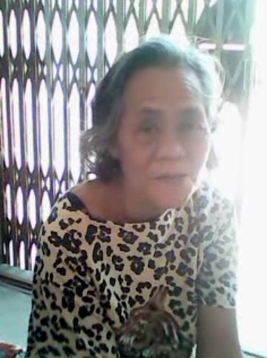
An elderly woman listening at our mission point in Neuava Ecija

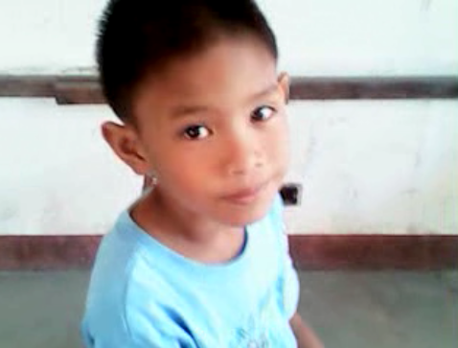
A young boy listening at our mission point in Neuava Ecija

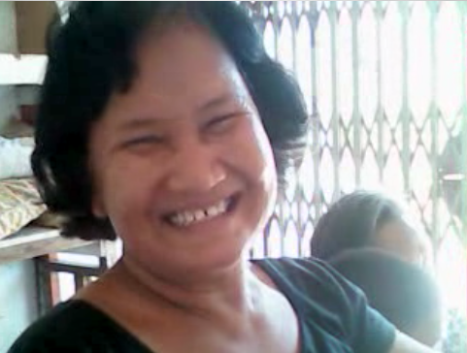
Sis Meding is a faithful Church worker and also assists at Neuava Ecija

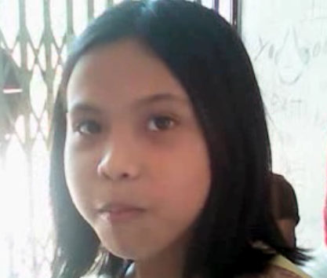
A young girl listening at our mission point in Neuava Ecija
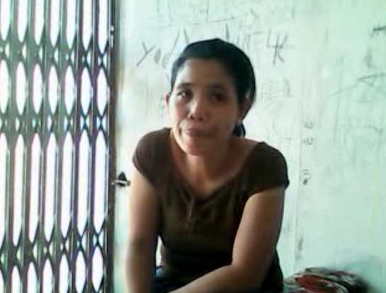
Another woman listening at our mission point in Neuava Ecija

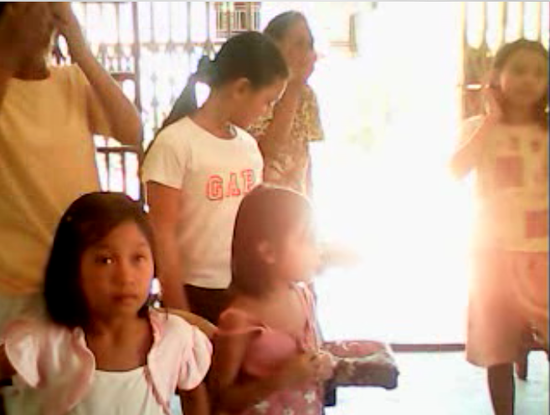
More people listening at our mission point in Neuava Ecija
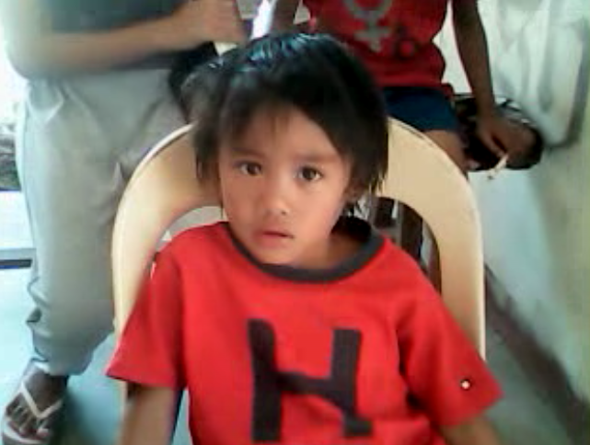
Another young boy listening at our mission point in Neuava Ecija

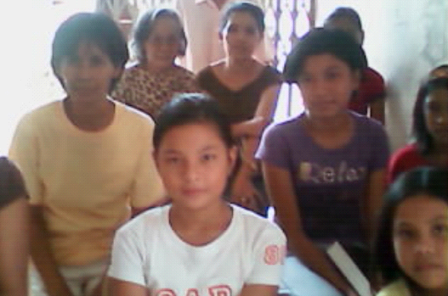
More people listening at our mission point in Neuava Ecija

